Line Following Robot

PROJECT NAME : LINE FOLLOWING ROBOT WITH TWO MOTORS AND TWO IR SENSORS.

PROJECT RELATED DESCRIPTION :

A typical line follower robot, It has two sets of motors, let's call them left motor and right motor. Both motors rotate on the basis of the signal received from the left and the right sensors respectively. The robot needs to perform 4 sets of motion which includes moving forward, turning left, turning right and coming to a halt. The description about the cases are given below.

**Moving** **Forward**

In this case, when both the sensors are on a white surface and the line is between the two sensors, the robot should move forward, i.e., both the motors should rotate such that the robot moves in forward direction (actually both the motors should rotate in the opposite direction due to the placement of motors in our setup. But for the sake of simplicity, we will call the motors rotating forward

.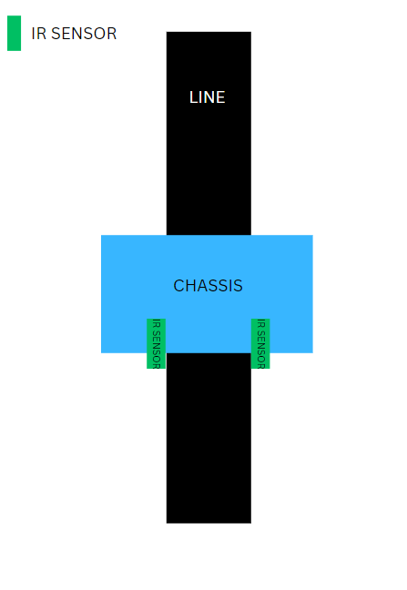

**Turning LEFT:**

In this case, the left sensor is on top of the dark line, whereas the right sensor is on the white part, hence the left sensor detects the black line and gives a signal to the microcontroller. Since, signal comes from the left sensor, the robot should turn in the left direction. Therefore, the left motor rotates backwards and the right motor rotates in forward direction. Thus, the robot turns towards the left side.

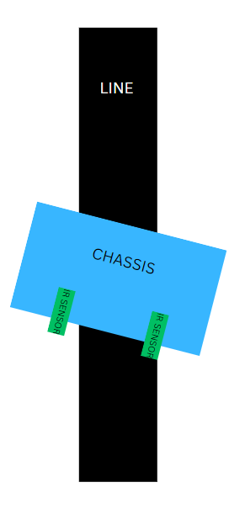

**Turning RIGHT:**

This case is similar to the left case, but in this situation only the right sensor detects the line which means that the robot should turn in the right direction. To turn the robot towards the right direction, the left motor rotates forward and the right motor rotates backwards and as a result, the robot turns towards the right direction.

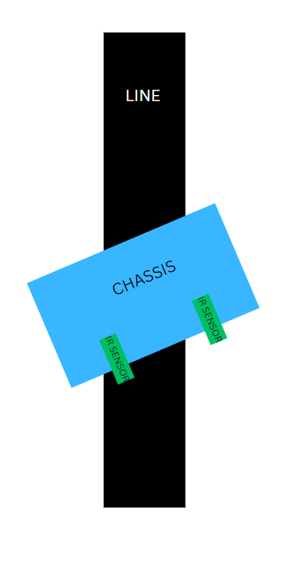

**Stopping:**

In this case, both the sensors are on top of the line and they can detect the black line simultaneously, the microcontroller is fed to consider this situation as a process for halt. Hence, both the motors are stopped, which causes the robot to stop moving.

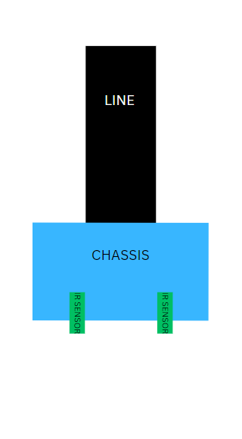

COMPONENTS USED IN THIS PROJECT :

IRON CHASSIS,

2 IR SENSORS,

2 WHEELS,

2 MOTORS,

1 ARDUINO UNO,

2 ROWS OF A BREADBOARD,

JUMPER WIRES,

1 MOTOR DRIVE,

SOLDERING KIT IS REQUIRED IN THE PROCESS.

1 9V BATTERY.

CIRCUIT DIAGRAM :

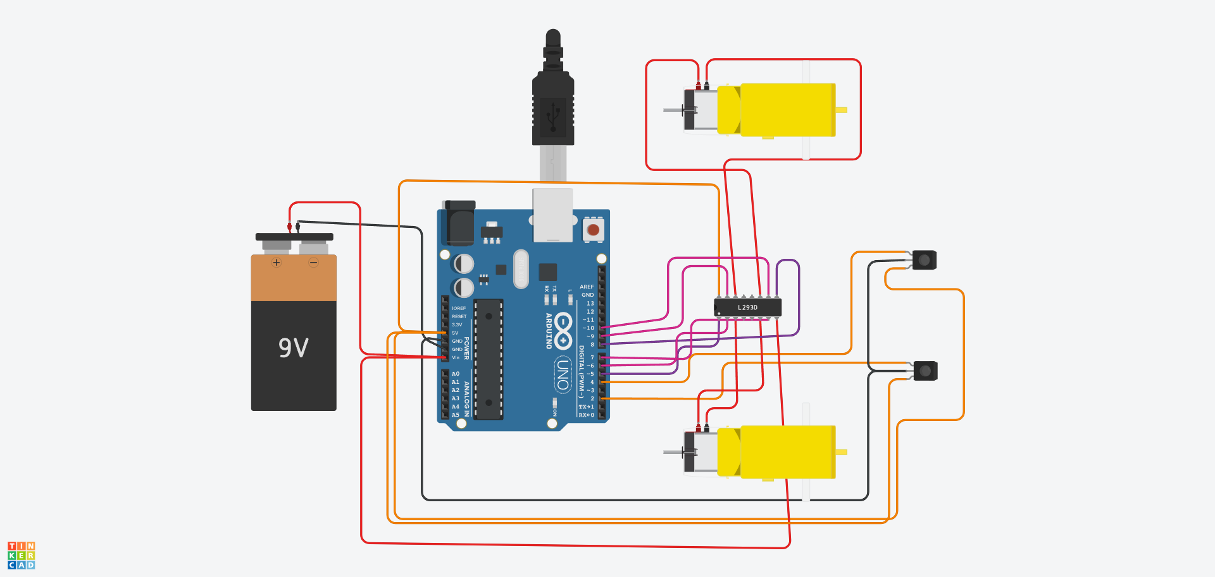

ARDUINO CODE :

https://drive.google.com/file/d/112MLs8VfZ7UV6Rv-fNBHBeGQlV3TlMvh/view?usp=drive_link